《與時共處》
何思瑋 個展

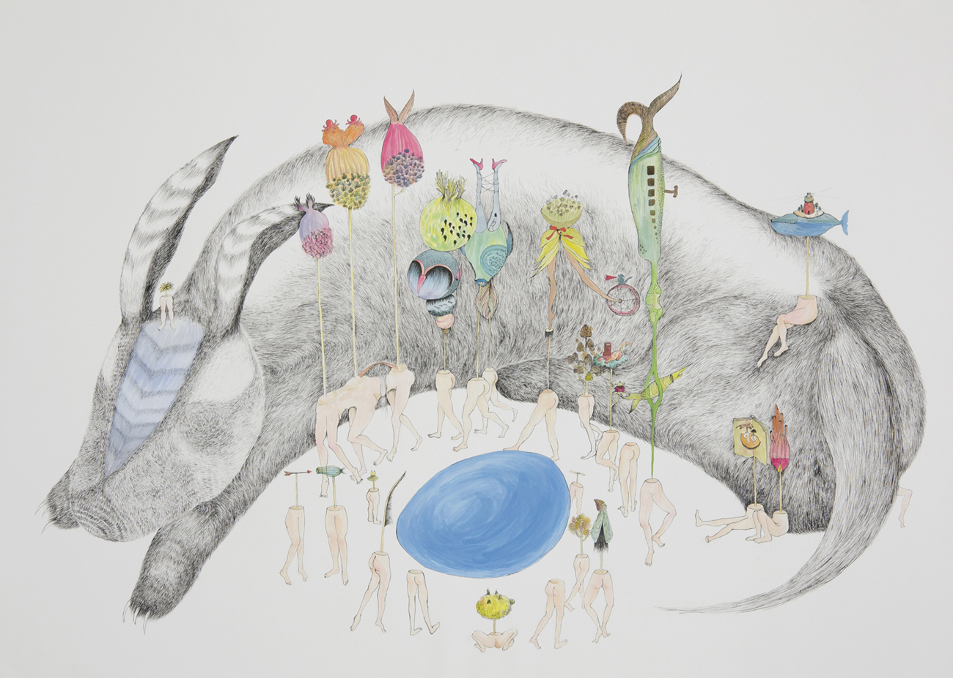
Blue Egg I, 2012

展覽地點：美華藝術協會｜456 藝廊
展場地址：456 Broadway, 3rd Floor. New York, NY 10013
開幕茶會：11月20日 (四) 下午 6-8 時
展覽日期：2014年11月20日至12月12日
藝廊開放：週一至週五 中午12-5 時
連絡電話：(212) 431-9740, (917) 834-3839
協會網址：www.caacarts.org
此次展覽由甘柏馨藝術基金會贊助。
美華藝術協會 | 456 藝廊系列展覽由 New York City Department of Cultural Affairs、New York State Council on the Arts贊助。

展覽說明

此次個展《與時共處》中，何思瑋想傳達出「時間」對於她在創作上的特殊意義。無論是靈感的發想或創作的過程，都需要時間來運作、沈澱、反芻。花點時間，才能慢慢理出頭緒，慢慢堆疊心中欲求的影像。

此次展出作品共分兩個系列。「島人」系列從2010年開始發展，探索的是藝術家的童年記憶、身體記憶跟身分認同。童年的記憶裡，因為總是留著長髮，常常跟著媽媽去學校對面的美容院裡洗頭、編辮子，在美容院裡接觸的人、事、物就成為她漫天發想的對象，頭髮也無形地化為印象中女性的重要象徵。而身體的記憶，存在於痛覺與視覺的感知。不管是從小到大不斷困擾她的牙套，還是青春期以後每次生理期的痙攣與作嘔，一次一次疼痛的感覺，與疼痛過後的留白，被刻印在記憶裡，轉化成另一種較似幽默的影像 。

另外一系列作品「藍蛋」，是何思瑋從2012年去Vermont 駐村開始的創作。由於當時在早晨林間的草地上發現一顆帶著新鮮血絲的藍綠色蛋殼，纖柔潤濕的血紋似乎暗示著生命的起始，啟發了她創作出藍蛋的旅程，並衍生出如生命祭典般的故事。

媒材方面，這兩系列分別使用了銅版蝕刻與素描，在銅板上跟在紙上的蝕刻與堆積，皆有時間累積的痕跡。經由視覺與觸覺，藝術家在創作過程中必須去察覺紙上油墨、鉛粉或顏料的堆疊，進而理出整張圖像的厚度與律動。

作品可反映藝術家本身，而何思瑋也是用此方式去認識她的逃避與嘗試面對。創造人物並賦予他們不同的角色，錯置他們於各種小世界，自是一種反省與出走。故事已說，也希望觀者看到的，是他／她們自己的故事。

Spending Time with Time
A Solo Exhibition of Szu-Wei Ho

Blue Egg I, 2012

Venue: Chinese American Arts Council / Gallery 456
Address: 456 Broadway, 3rd Floor. New York, NY 10013
Opening reception: Nov 20th, Thursday, 6-8 PM
Exhibition date: Nov 20th – Dec 12th, 2014
Gallery hours: Monday to Friday, 12-5 PM
Telephone: (212) 431-9740, (917) 834-3839
Website: www.caacarts.org
The exhibition is generously supported by Pak-Hing Kan Arts Foundation.
“CAAC | Gallery 456 Visual Arts Exhibition Series” is supported, in part, by public funds from the New York City Department of Cultural Affairs, in partnership with the City Council. This program is also made possible by the New York State Council on the Arts.

Statement

The exhibition title Spending Time with Time entails the importance of “time” in Szu-Wei Ho’s work. No matter it is the inspiration or the process of creation, time lets her work, lets the mind rest and rethink. She take time to create the image, and let it accumulate slowly into the picture in mind.

Two series of work are shown in the exhibit. “The Islanders” is a series about Szu-Wei’s childhood memory, body, and identity. When she was little, her mom would take her to the hair salon across from school quite often. Everything she encountered over there intrigued her, and also lured her into believing hair is one vital element of female image. The memory of body, for her, resides in the sense of pain and vision. No matter it’s the braces which trapped her for years over childhood/teenage, or the overwhelming cramps during menstruation. Pain and relief take turns making marks in her body and mind, which later turns into images that are light and humorous.

The other series of work, “Blue Egg,” dates back to the residency program at Vermont. She spotted a Robbin’s egg on the grass while taking a stroll in the morning. The egg was empty, broken, wet with dew and blood. The bright blue-green color jumped out of space, while the feather-shaped blood vein still clinging in the shell. The journey of the blue egg therefore begins, with a festival celebration planned.

Intaglio and drawing are the main medium Szu-Wei use. Whether it is the acid biting into the copperplate or ink/lead accumulating on paper, they both represent the traces of time. By seeing and touching, she tries to feel the thickness of color and the movement of the whole picture.

Every time Szu-Wei looks back at her own work, she gets to learn more about her escape and coming back. Creating characters and placing them into different worlds is her way to deal with confrontation and a gateway for freedom. Stories are told, and hope the viewer could also find their own ones.

